Hop Research Council 2022 Research RFP
June 20, 2021

Project Title: Evaluating Electric Weed Control in Hops

Project summary: Weed Management in hops is reliant on chemical weed control. The chemical weed control approach faces challenges on residue tolerances, limited versatility of products to be used in season, and cases of herbicide-resistant weeds. Non-chemical weed control options that are both practical and compatible with the hop production system are needed. This proposal will evaluate electric weed control in hops, a novel technology in weed control that controls weeds applying high voltage. The benefits of electric weed control include no chemical residue, no soil tillage, and root activity with efficacy against perennial weeds. At least three European companies manufacture electric weed control units, Zasso, Crop Zone, and Root Wave. OSU Horticulture purchased a commercial unit (EH 30 Zasso) to work on herbicide resistance management in hazelnuts and weed control in organic blueberry. Initial results indicate excellent control of Italian ryegrass, horsetail, Canada thistle, yellow nutsedge, and field bindweed up to 4 weeks after treatment. A cursory test in hops using 8,000 V suggests EWC affects only the area treated while the plants are still alive after four weeks. This was a first test based on observations only, with no measurement. Before growers can consider investing in this technology, more information is needed to determine the best timing of application, speed of operation, placement of electric treatment, and crop tolerance. As electricity is applied to hop shoots, it is possible that one can control other organisms like powdery mildew during spring pruning, but that is unknown. The findings of this study will help the hop industry reduce its reliance on chemical weed control, moving the whole industry towards more sustainable production practices.

Proposed Duration:
Project duration of two years (2022-2023); this document is for year one (2022).

Project leader:

Marcelo L Moretti, Assistant Professor Weed Science, Oregon State University, office (541) 737-5454; marcelo.moretti@oregonstate.edu; Dept. of Horticulture, Corvallis, 4017 Agriculture & Life Sciences Building, OR 97331.

Cooperators: n/A

Funds requested:
2022: $12,000

Other Funding Sources and Support:
None at this time. I hope to pursue federal funding if this technology is safe for the crop. This project aims to create preliminary data to support more extensive federal proposals in the near future.

Send Funds to:
Agricultural Research Foundation, 1600 SW Western Blvd., Suite 320
Oregon State University, Corvallis, OR 97333.
Attn: Charlene Wilkinson Phone (541) 737-3228 Email: Charlene.Wilkinson@oregonstate.edu
Project Title: Evaluating Electric Weed Control in Hops

Statement of Problem:
The hop industry is interested in non-chemical weed control options to cope with the MRLs restrictions that the industry is facing. A weed control option that does not rely on soil tillage may also bring the benefit of improving soil health in the long term. Electric Weed Control (EWC) is an emerging technology that is expanding in many countries in Europe and South America. EWC control weeds by directly applying high voltage to foliage that will heat the plants from inside out and kill them. OSU Horticulture Weed Science is actively studying EWC for management in hazelnuts and blueberry in Oregon. Our initial test indicates that EWC may have a place in hop production. However, equipment development and field testing are needed to ensure we identified the best opportunities to incorporate this technology safely in hop production.

Relationship to Hop Research Council Research Priority:
Priorities directly related to this project:
Agronomic Research
3.Non-chemical or no-tillage options for weed management (sustainability)
7.Non-chemical burnback (steam/electric)
8.Herbicide resistance management
Disease Research
- Mitigation of export market access issues due to MRL’s (I argue this is also applicable to herbicides!)

Objectives:
- To evaluate hops response to electric weed control applied in winter dormant, spring pruning, or season.
Justification and importance of proposed research:
This project address multiple research priorities identified by the Hop Research Council. Electric weed control (EWC) systems generate a high voltage current applied directly to the target plant via foliage contact and conducted downward through the roots. As the current passes through the plant, electrical resistance generates heat; this results in the vaporization of cellular water, leading to cell membrane rupture and plant death (Bauer et al. 2020; Diprose et al. 1984). EWC is a thermal weed control method. The first electric weeders were patented in the 1880’s (Vigneault and Benoît 2001). In the 1970s and 1980s, EWC was successfully used in sugar beets to control weeds and bolting crop plants with the Weed Zapper unit (Diprose et al. 1984; Diprose et al. 1985; Wilson and Anderson 1981). The dimensions and horsepower requirements of the Weed Zapper preclude its use in hops and other perennial crops. Other companies (none US-based) have developed similar technologies for urban weed control and weed control in specialty crops. These include Crop Zone (https://crop.zone/), Root Wave (http://rootwave.com/), and Zasso (https://www.zasso.com). The Horticulture Department with Oregon State University has recently acquired a Zasso EH30 unit (Figure 1), and research started in the spring of 2021. Operation speeds range from 0.8 – 8 km hr⁻¹. The EH30 unit employs electrodes lower to the ground creating continuous contact with soil or plant foliage and effectively electrifying even prostrate plants like knotweed, puncturevine, and field bindweed.
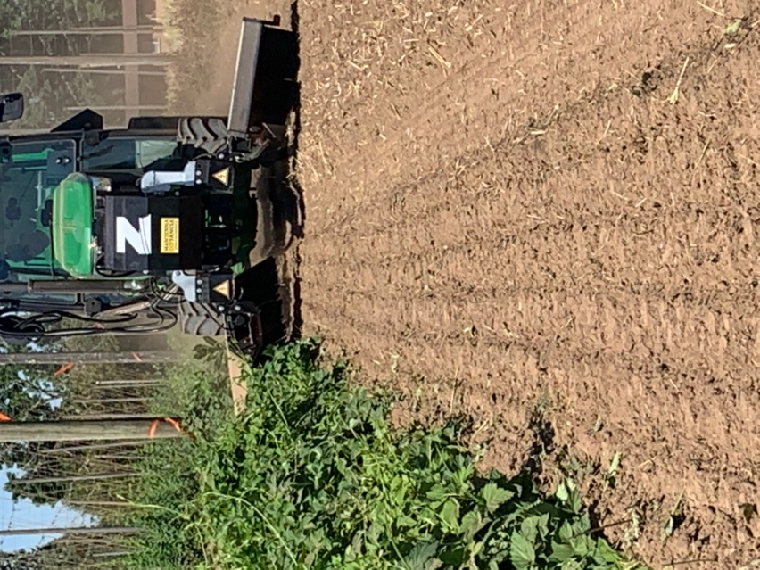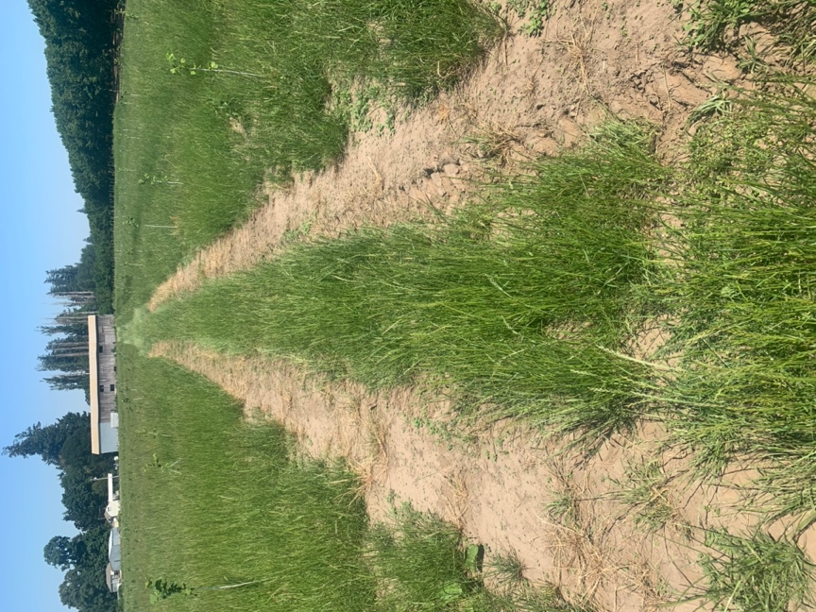
Figure 1. Electric weed control system EH 30 in a hop yard in Hubbard, OR the Spring of 2021 (left). An example of control of EH 30 at one mph in 3 ft tall Italian ryegrass in a hazelnut orchard in Salem, OR (right). The picture was taken two weeks after treatment.

I believe that electric weed control (EWC) can play an important role in weed management in the conventional and organic hop. A primary selling point is that EWC does not disturb the soil, which is necessary for improving soil health production (Brodie et al., 2018; Sahin and Yalınkılıc 2017). The ability of EWC to substantially injure the roots, rhizomes, and bulbs of perennial weeds would be invaluable to growers battling the most difficult to control species. Unfortunately, there is a knowledge gap describing how electric weeding technology will perform in hops.
As the electricity is applied to the plant foliage, it moves within the plant for as long as the plant electric resistance is lower than the soil resistance. Plant electric resistance varies among species, age, and tissue. In general, woody tissues have higher electric resistance, do not conduct electricity very well; thus, they may tolerate electricity better than non-woody tissues or non-woody plants. EWC damage seems restricted to the directly treated tissue on a cursory first test and not killing the whole plant and root system two weeks after treatment (Figure 2). Tissue necrosis is a good indicator of tissue death. These encouraging results suggest using EWC in hops to control weed in a row, perhaps, even during the growing season.

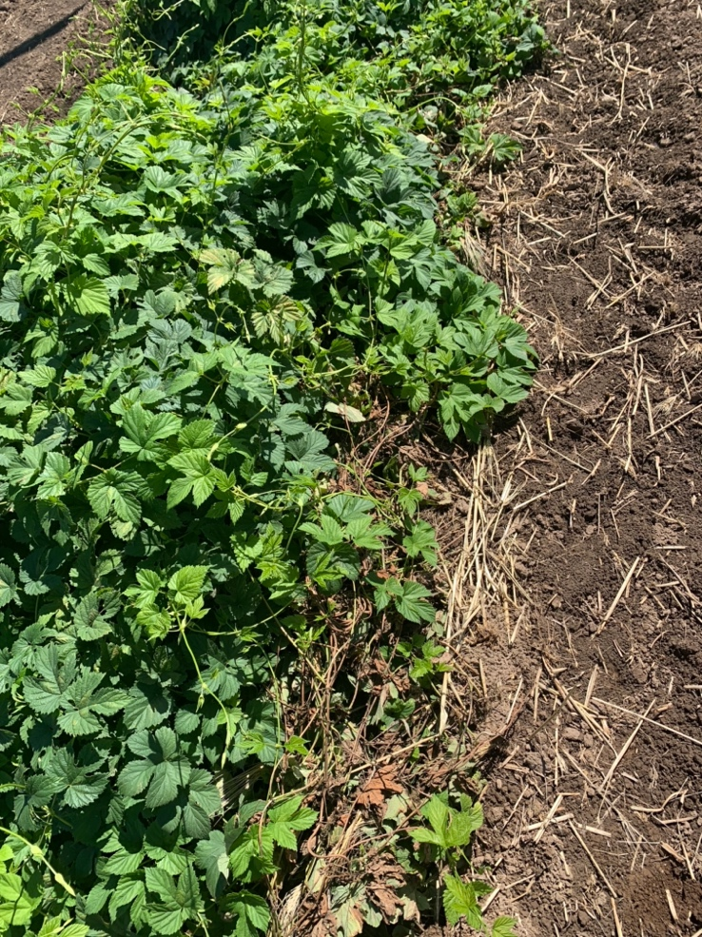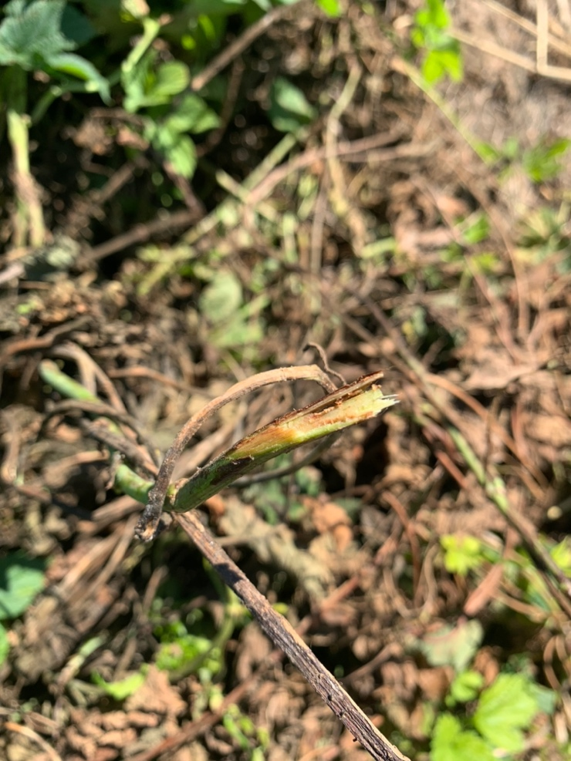
Figure 2. Overview of hop cv ‘Nugget’ two weeks after electricity application in Hubbard OR (left). A close-up of electricity damage to hop shoots.
Procedures:
To evaluate hops response to herbicides tiafenacil, tolpyralate, and florpyrauxifen-benzyl.

A field study will be conducted in research hop yards cv ‘Cascade’ to be planted in July 2021 at the OSU Lewis Brown research farm in Corvallis. The experiment will consist of a three by three factorial design organized as a randomized complete block with four replicates. The first factor will be the three application timings: dormant (Jan-Feb), spring pruning (April), or in-season (June). At each application timing, three treatments will be included. (1) EWC at 0.25 mph at the highest voltage setting ~8,000V, (2) EWC at 1.25 mph at the highest voltage setting, and a standard reference. Glyphosate will serve as the reference for winter burndown, while carfentrazone will reference both spring pruning and in-season application. Hops will be trained and grown for the entire season. Treatments will be applied by a back-pack sprayer calibrated to deliver 20 GPA and equipped with drift-reduction nozzles generating coarse droplets. EWC will be applied using an EH 30 (Zasso) mounted on a JD 5100N.
The experimental unit (plot) will include three hop plants (six strings). Evaluations will consist of visual estimation of crop injury in the treated zone (hop base), above the treated area (crop injury), and crop height. Leaf chlorophyll content will be measured using a non-destructive sample based on chlorophyll fluoresce ratio F735/F700 (Gitelson et al. 1999). Assessments will be made throughout the growing season. Plants will be harvested using a commercial picker (5p, HopsHarvester, Honeoye Falls, NY). Data will be submitted to ANOVA and means compared by Tukey’s test.

Outcomes:
The findings of this project will identify new weed control methods for use in hops. Additional non-chemical weed control options may provide growers new tools to manage difficult to control weeds, manage herbicide resistance, reduce tillage, and promote better soil management practices. If successful, EWC is compatible with pre-emergence herbicides, drip irrigation, and it does not generate dust. In preparation for this project, our cursory test indicates that the electrode design will need to be changed to improve the contact with the weeds around the hop planting. We believe that placing the applicators higher above the crop and equipped with longer electrodes, the metal finger touching the ground, can improve contact with weeds and hop shoots.

Extension and Outreach activities:

Research findings will be shared during the Hop Research Council and other events.

Time-frame

The research for the second year of study will be conducted from March 2022 to October 2022. Data analysis and reporting will be available for the Hop Research Council by the end of the calendar year 2022.

Anticipated work future years (2023)

The goal of this project is to generate initial results supporting that EWC has application in hop production. Once tolerance is established for 2022, we will repeat the study on the same plants in 2023. This project might expand in the future years to include EWC uses in commercial production.

References:

Gitelson, Anatoly A., Claus Buschmann, and Hartmut K. Lichtenthaler. “The chlorophyll fluorescence ratio F735/F700 as an accurate measure of the chlorophyll content in plants.” Remote Sensing of Environment 69.3 (1999): 296-302.
Heap, I., 2020. The International Survey of Herbicide Resistant Weeds. http://weedscience.org/, Accessed date: September 02, 2020
[HRC] Hop Research Council, 2019. The Hop Research Council Research Priorities. http://hopresearchcouncil.org/. Accessed date: November 05, 2019.
Norsworthy, J. K., Ward, S. M., Shaw, D. R., Llewellyn, R. S., Nichols, R. L., Webster, T. M., ... & Witt, W. W. (2012). Reducing the risks of herbicide resistance: best management practices and recommendations. Weed Science, 60(SP1), 31-62.
Diprose M, Benson F, Willis A (1984) The effect of externally applied electrostatic fields, microwave radiation and electric currents on plants and other organisms, with special reference to weed control. Bot Rev 50:171-223
Diprose M, Fletcher R, Longden P, Champion M (1985) Use of electricity to control bolters in sugar beet (Beta vulgaris L.): a comparison of the electrothermal with chemical and mechanical cutting methods. Weed Res 25:53-60
Vigneault C, Benoît DL (2001) Electrical weed control: theory and applications. Pages 174-188 in Vicent C, Panneton B, Fleurat-Lessard F, eds. Physical control methods in plant protection. New York, NY, USA: Springer-Verlag Berlin Heidelberg
Wilson R, Anderson F (1981) Control of three weed species in sugarbeets (Beta vulgaris) with an electrical discharge system. Weed Sci:93-98

Budget

Budget:
Expenditure | Total amount requested (2022)
Salaries – Faculty research assistant | $ 3,000
Employee benefits (76 %) | $ 2,280
Undergraduate students ($17/h) | $ 820
USA hop and summer meeting | $ 1,900
Materials ( applicador) | $ 4,000
Total | $12,000

Budget Narrative

Salaries: $3,000 funding for 0.07 FTE equivalent for a Faculty research assistant. The annual salary was calculated at $46,150. Other payroll expenses include 76% benefit at $2,280. https://research.oregonstate.edu/osraa/forms-and-rates/other-payroll-expense-ope-information-and-estimated-rates)
Salary for 48 h of undergraduate student assistance is requested at $820 at $17/h, including benefits. Students are assisting with hop planting, training, irrigation, and harvest.
USA Hops and summer meeting – we request $1,900 to attend the HRC summer meeting and the USA hop meeting.
Materials. We request $4,000 to design and purchase a new applicator better suited for hops.

