Project Title:
Novel control methods for California prionus beetle using entomopathogenic fungi

Executive Summary:
In the first year of this project, we determined through extensive laboratory testing that entomopathogenic nematodes were not going to be effective biological control agents for the California prionus beetle. Last year, we altered our original plan. We proposed to optimize control of CPB using entomopathogenic fungi (EPF). EPF are pathogens of insects widely found in soil and can contribute to CPB management. California prionus beetle (CPB) is a significant pest of commercial hops throughout the Pacific Northwest. The larvae and adult beetles present significant management challenges for growers when they are present. Historically, CPB management has relied on fumigation of hop yards before planting, pheromone traps for mating disruption and monitoring, and the use of insecticides such as ethoprop (e.g., Mocap EC). Unfortunately, these approaches do not meet current grower needs. EPF are commercially available and are effective against a number of insect pests. We tested several products containing entomopathogenic fungi (EPF) with the intent to deploy these pathogens using an autodissemination plan. Briefly, the adult beetles are attracted to a trap where they are exposed to EPF, infected, and then released. The CPB then succumb to the infection and produce new infective spores, which are environmentally stable and can infect new insects when they come into contact with them. During extensive laboratory testing, we have found several candidate EPF that infect and kill CPB, and within a week produce infective spores on the CPB cadavers. These infective spores, in turn, are highly pathogenic to CPB adults they contact.

Proposed Duration:
Year 2 complete, Year 3 proposal

Project Leader:
Edwin Lewis, Professor
University of Idaho
Department of Entomology, Plant Pathology, and Nematology
eelewis@uidaho.edu
(208) 885-1697
875 Perimeter Drive MS 2329
Moscow, ID 83844
Co-PL or Technical Assistance:

Glen Stevens, Lab Manager
University of Idaho
Department of Entomology, Plant Pathology, and Nematology
glens@uidaho.edu
(540) 267-5820
875 Perimeter Drive MS 2329
Moscow, ID 83844

Cooperators:
Diane and Michelle Gooding
Gooding Farms, Inc.
23669 Batt Corner Rd
Parma, Id 83660

Amount Requested:
$22,000

Other Funding Sources and Support
Other funding to contribute to the success of the proposal includes support for salary provided by Dr. Lewis to support Dr. Stevens through a number of other funding sources not related to this work.

Send Funding To:

HOLLY WATERS, Director
College of Agricultural and Life Sciences
Grant Management Services, Ag Science Room 304
hwaters@uidaho.edu
208-885-5999
875 Perimeter Drive, MS 2337

Project Title:
Novel control methods for California prionus beetle using entomopathogenic fungi

Statement of Problem:
The California prionus beetle (CPB) is a major pest of hops. Larvae live and feed on the roots of hop plants, resulting in decreased uptake of nutrients and water. This stress can result in wilting and, in severe instances, plant death. Secondary bacterial infections of the roots can also result from feeding damage. Current pest management revolves around monitoring, fumigants, and the use of Mocap EC. Unfortunately, these control methods are often ineffective. As such, new pest management strategies are needed to control problematic populations of CPBs to reduce crop damage. Management of this pest species is vital for the continued success of hop growers in the Pacific Northwest and the United States. We propose to develop improved control methods which utilize entomopathogenic fungi (EPF) for CPB management.

Justification and Importance of Proposed Research:
In 2019 Hop production encompassed 56,544 acres in Washington, Idaho and Oregon (NASS, National Hop Report). Integrated pest management (IPM) of CPB is notoriously difficult, with a limited range of chemical management options available. While CPB is generally thought of as a problem in Western Idaho, infested fields can be found throughout the Pacific Northwest. Indeed, CPB adults were seen in Boundary County, ID during the summer of 2021 (personal observation). Current management includes pre-planting fumigation, which costs > $350/ acre (Galinato and Tozer 2016); and can be done only one time in the life of a hopyard and the cost does not include removing the trellis systems. Curative treatment management relies on Mocap EC, a restricted used organophosphate with a 90 day preharvest interval (Barbour 2019). Alternatively, physical management can include removal of infested plants and fields in severe circumstances. Due to the limited options for physical and chemical control, new IPM is needed for the control of problematic populations of CPB. To this end, we proposed to develop novel approaches using entomopathogenic nematodes of the in-soil larval stages of the beetle.
In year 1 of this investigation, we set out to examine whether entomopathogenic nematodes could be used to control CPB by infecting the larval stage of this insect. CPB larvae were collected in the fall of 2020 and 2021 and screened with a suite of different nematode species and rates, and the addition of nematode related pheromones. Through a significant screening endeavor, we were only able to infect prionus larvae with Steinernema glaseri and Steinernema riobrave at a success rate of approximately 20%. While this adds significant new information to the scientific community, it is well below the needed threshold for an integrated pest management program to control CPB. Working within this same pest species, we pivoted pest management strategies to incorporate the use of entomopathogenic fungi (EPF). These fungi are pathogens of insects and have been previously incorporated into integrated pest management plans for multiple different species of agricultural pests, including aphids, beetles, lygus bugs and multiple other arthropod species. Currently available species of EPF which could be screened against CPB include Beauveria bassiana, Cordyceps fumosorosea, Akanthomyces muscarius, Metarhizium anisopliae, Purpureocillium lilacinum, and Trichoderma harzianum. This pivot resulted in targeting the adult above ground life stage and not the larval stage. Further, after initial infestation, the beetle can be released to spread the fungi to other CPB that they come into contact with before they die. This method is known as autodissemination. This pivot will require no funds beyond our original request for the third year, and we believe we can complete the project within the original timeframe outlined in our proposal.
Autodissemination IPM plans require 5 conditions to be successful: (1) A mobile stage of the target insect (adult CPB are highly mobile), (2) A strong and reliable attractant and trapping system (CPB sex pheromone is effective and commercially available), (3) an insect pathogen that can infect and kill the target insect (our new data supports this, see Figure 1), (4) infective stages of the pathogen must develop within the infected target (our new data also show this), and (5) the infective stages produced by the target cadaver must be able to infect healthy individuals of the same species (our new data show this as well). The pieces are all in place; we will now work on deployment.
Objectives:
- Determine optimal EPN species for CPB control by laboratory and greenhouse tests.
  - This objective led to the change in strategies to focus on EPF.
- Screen multiple products/species of EPF for pathogenicity to and reproductive outcomes within CBP.
- Develop a pheromone based CPB trap that will expose the beetles to lethal doses of EPF and allow their release thereafter.
  - This is a new objective to be completed before the 2023 beetle flight.
- Conduct field trials with optimized EPF species and application methods at Gooding Farms.
  - This objective has changed but will be conducted summer 2023.
5) Develop extension bulletins and guidelines for growers for the use of EPNs to control CPB larvae and other soil dwelling pests of hops.

Procedures/Methods to accomplish objectives:
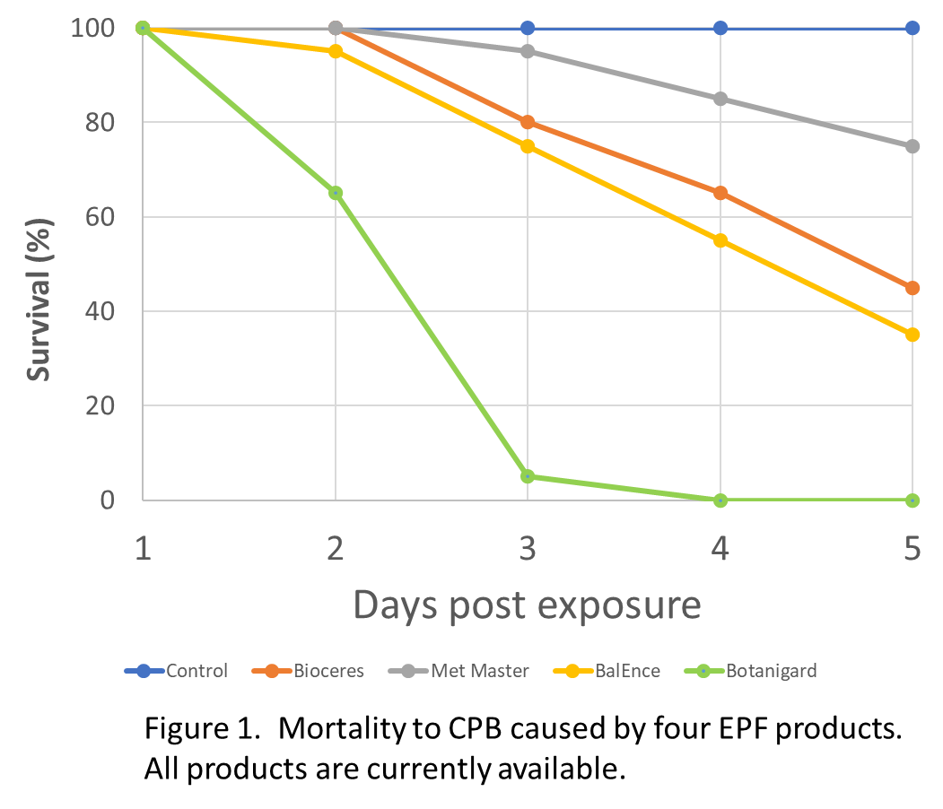
Objective 2:
We screened four products, based on either B. bassiana or M. anisopleae against CBP during summer, 2023. As can be seen in Figure 1, the product Botanigard 22WP (green line), based on B. bassiana was the most effective. Further, the infective spores of the fungus produced by the CPB cadaver were at least as pathogenic as the product. We will concentrate on this product hereafter. When larvae can be collected, we will conduct similar assays against them in the laboratory. When the adults disseminate the EPF, we need to know what the potential impact on larvae will be. Based on studies with other insect species, when adults are susceptible to infection, the larvae are as well.

Objective 3:
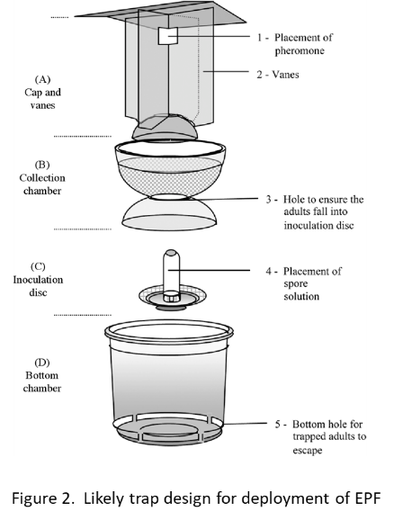
We are working currently on a trap design that will lure adult males to the trap, expose them to the pathogen of interest (Botanigard 22WP is the likely candidate) and let them escape after they have been exposed and infected. Several different trap designs have been developed for other pests, and we have reviewed them at some length. The likely design will be something similar to that shown in Figure 2, adapted for an in-ground deployment. We are using 3-D printing technology to fabricate the parts we need.

Objective 4:
Field trials will be conducted in three different hop yards with a history of CPB infestation. The proposed field trials may require destructive sampling at the end of the season to assess CPB larval numbers but monitoring adult numbers will not require this. Specific field locations will be chosen in consultation with growers.
Traps (developed in objective 3) will be deployed when the first males are caught in sentinel traps; this will likely occur in mid-June. The field locations will be divided into two sections each, one with traps that include EPF and the other location will have an equal number of traps without EPF. The traps will be in place for 4 weeks. At the end of this period, the traps with EPF will be cleaned and further trapping will aim to assess populations of CPB. Plant vitality will be assessed throughout the growing season. Hop plants will be allowed to grow and destructively sampled for CPB and damage at the end of the growing season. Roots will be dug at the end of the growing season and rated for damage and recovered CPB will be recorded. Insects will be collected and brought back to the lab to be monitored for the presence of EPF infection. During the experiment, we will also note the presence of black vine weevil and false wireworm, both susceptible to EPF infection.

Objective 5:
To provide guidance for growers on the use of EPF in IPM we will compile extension bulletins through the University of Idaho Extension Department on the use of EPNs in hop pest management. Bulletins will be developed by the PIs and will be provided as open access (free of charge) through University of Idaho Extension. The primary focus of this objective is to make the findings of this study impactful and easily incorporated into hop IPM.

Outcomes:
The overall outcome of this research is to provide hop growers an effective control method for CPB using autodissemination of EPF. With the optimization experiments outlined above, we expect to develop science-based, publicly available information to this end.

Outcomes for Objective 1) Through laboratory testing of EPNs, we have determined that this approach will not be effective.

Outcome of Objective 2) We have determined that EPF can be effectively deployed against CPB adults. Further effort will determine this efficacy against CPB larvae.

Outcome of Objective 3) An effective trap/release apparatus is under development currently.

Outcome of Objective 4) A field trial will allow us to assess the impact of EPF deployment. Follow-up monitoring of these areas will further inform the longer-term impact of EPF.

Extension and Outreach Activities:
All information generated during this project will be presented at the Hop Research Council Meetings and entomological conferences, incorporated into University of Idaho Bulletin, and written into a per reviewed academic journal. The overall goal of this research is to develop new management practices that will benefit hop growers in real time and provide hop growers with another tool for pest management in hop yards.

ATTACHMENTS

Time Frame for Objectives:

FY2022
May-September
- EPFs were evaluated against CPB adults in the laboratory
- Several species/strains were effective against the adults
- Further testing of the infectivity of EPF conidia produced by CPB cadavers against uninfected CPB showed that they were also highly effective killing CPB adults
September-December
- Trap designs are evaluated for deployment
- Fabrication of traps begins

FY2023
January- May
- Trap design is refined and fabrication of units for field deployment is completed
May-September
- EPF autodissemination units will be installed to field trial areas upon the first detection of adults in the area
- CPB populations monitored and bi-weekly plant health assessment for bines will be conducted
September-October
1) Hop plants will be dug and beetle numbers and damage to the root system will be examined. Samples will be transported to the University of Idaho main campus for assessment of infection by EPF.
November-January
1) All findings will be written into a scientific journal and extension bulletin.

Project Budget:
Expenditure | Hop Research FY2023
Salaries¹ | 7,052
Employee Benefits | 2,948
Temporary or hourly workers | 1,500
Travel² | 3,000
USA Hop Convention Registration | 800
Grower Field Compensation | 3,000
Equipment | 0
Lab Supplies (including EPFs) | 2,700
Publication Fee | 1,000
Total | 22,000

¹ CO-PD Glen Stevens will commit 0.12 FTE ($7,052/year for FY2023). Dr. Stevens primary function will be to assist with assessment of EPFs to be tested within field locations, data analysis. Benefits for Dr. Stevens are calculated at 41.8% per year ($5,896 total for 2 years)
² One of the project directors will travel to the annual Hop Research Council Meetings once a year. Extensive travel for one of the project directors back and forth between Moscow and southern Idaho will be more necessary now that Dr. Clements is not part of this project.

Other Funding Sources and Support:
Other funding to contribute to the success of the proposal includes support for salary provided by the technician to conduct field work at the Parma Research Station, now supervised by Dr. Lewis.
Literature Review:
The production of hops is vital for the continued success of brewing. The hop plant, Humulus lupulus, produces flowers (cones) which are harvested for the oils that they contain. The oils are used in the brewing process for their bittering attribute, stability, and preservation of the fermented product. The hops industry in the United States has boomed in recent years, with a 5% increase in production from 2018 to 2019 resulting in revenue of $637 million (NASS, Hops). The production of hops has been adapted to trellis format and is commonly describe as hop yards. The initial financial comment to generate a hop yards is upwards of $14,000 per acre (Michigan State University, Extension) and requires thousands of dollars in pest management control during the life of the yard (which can exceed 10 years).
There are multiple pest species that grower’s mange in order to provide a clean product to consumers, including plant pathogens and arthropod pests. Arthropod pests of hops include mites and insects. Some common pests are two spotted spider mite, black vine weevil, aphids, California prionus beetle and others. One of the major pest species that hop growers mange is the California prionus beetle (Prionus californicus) (CPB). This species is one of the largest beetles found in the United States. While adult CPB can be present in high numbers during the growing season, the adult life stage does not feed upon hop plants. Instead, the damage to the hop plant is the result of the feeding of the larval stage on roots (Barbour et al. 2006). Larvae take multiple years to mature within the hop fields, and during development they continually feed on the root system and burrow into root tissue (Field guide for Integrated Pest Management of Hops, 2017). Damage from larval feeding results in tissue death, loss of nutrient and water movement through the hop plant, and secondary infections from pathogens (Barbour 2011). Fiscal cost of damage from feeding larvae can be hard to quantify because pest management activities range from removal of infected plants to removal of infected fields (Beetles, Hop Integrated Pest Management, 2017). Current chemical management relies on the use of pre-planting fumigants, monitoring of adult male beetles through pheromone traps, and the use of Mocap EC (Barbour 2011).
The use of EPF in IPM has been established as a biological control method for multiple pest species (Skinner et al. 2014). The EPF life cycle is ideal for deployment in autodissemination systems when certain conditions are met. These conditions have been described elsewhere in the document. Successful deployment of EPF has been achieved against Japanese beetles (Klein and Lacey 2010), tsetse flies (Maniania and Ekesi 2013), black vine weevil (Pope et al. 2018) and many other insect species. To use this technique against CPB successfully requires the optimization steps outlined in this proposed work.
The current lack of registered chemicals and the development of chemical resistance in multiple pest species of hops warrant the investigation of new approaches for pest management. Through revisiting and revising current pest management approaches, science-based extension recommendations can provide guidance to growers for sustained crop production, including developing new biorational pest controls to mitigate off target effects, prevent insecticide resistance, and provide a lasting improvement on environmental impact. With proper management, hop production in the Pacific Northwest and the United States will continue to flourish.

References:
- Barbour, J. D., Alston, D. G., Walsh, D. B., Pace, M., & Hanks, L. M. (2019). Mating disruption for managing Prionus californicus (Coleoptera: Cerambycidae) in hop and sweet cherry. Journal of economic entomology, 112(3), 1130-1137.

- Barbour, J. D., Cervantes, D. E., Lacey, E. S., & Hanks, L. M. (2006). Calling behavior in the primitive longhorned beetle Prionus californicus Mots. Journal of Insect Behavior, 19(5), 623.

- Barbour, J. D., Millar, J. G., Rodstein, J., Ray, A. M., Alston, D. G., Rejzek, M., ... & Hanks, L. M. (2011). Synthetic 3, 5-dimethyldodecanoic acid serves as a general attractant for multiple species of Prionus (Coleoptera: Cerambycidae). Annals of the Entomological Society of America, 104(3), 588-593.

- Bender, G. S., Bates, L. M., Bethke, J. A., Lewis, E., Tanizaki, G., Morse, J. G., & Godfrey, K. E. (2014). Evaluation of insecticides, entomopathogenic nematodes, and physical soil barriers for control of Diaprepes abbreviatus (Coleoptera: Curculionidae) in citrus. Journal of economic entomology, 107(6), 2137-2146.

- Klein, M.G. and Lacey, L.A. (2010) An attractant trap for autodissemination of entomopathogenic fungi into populations of the Japanese beetle Popillia japonica (Coleoptera: Scarabaeidae). Biocontrol Science and Technology. 9, 151-158.

- Galinato, S. P., & Tozer, P. R. (2016). 2015 estimated cost of establishing and producing hops in the Pacific Northwest.

- Maniana, N.K. and Ekesi, S. (2013) The use of entomopathogenic fungi in the control of tsetse flies. Journal of Invertebrate Pathology. 112, Supplement 1. S83-S88.

- Michigan State University Extension (2014) Estimated Costs of Producing Hops in Michigan. Available at https://www.canr.msu.edu/uploads/resources/pdfs/estimated_costs_of_producing_hops_in_michigan_(e3236).pdf

- NASS USDA. (2019) National Hop Report. Available at https://www.nass.usda.gov/Statistics_by_State/Regional_Office/Northwest/includes/Publications/Hops/National%20hop_2019.pdf

- O’Neal, Sally D., D. B. Walsh, D. H. Gent, J. D. Barbour, R. A. Boydston, A. E. George, D. G. James, and J. R. Sirrine. "Field guide for integrated pest management in hops." US Hop Industry Plant Protection Committee, Pullman, WA (2017).

- Pope, T., Hough, G., Arbona, C., Roberts, H., Bennison, J., Buxton, J., Prince, G., Chandler, D. (2018) Investigating the potential of an autodissemination system for managing populations of the vine weevil, Otiorhynchus sulcatus (Coleoptera: Curculionidae with entomopathogenic fungi. Journal of Invertebrate Pathology. 154, 79-84.

- Skinner, M, Parker, B.L. and Kim, J.S. (2014) Role of entomopathogenic fungi in integrated pest management. In: Integrated Pest Management: Current Concepts and Ecological Perspective. (Edited by D.P. Arbol). Academic Press.

Curriculum Vitae
Edwin E. Lewis

Education
Ph.D. Entomology. 1991. Auburn University, Auburn, AL.
M.S. Entomology. 1987. University of Missouri, Columbia, MO.
B.S. Natural Resources. 1980. Cornell University, Ithaca, NY.
A.A.S. Science and Mathematics. Cayuga County Community College, Auburn, NY.
Professional Experience
Current Professor, Dept. Entomology, Plant Pathology and Nematology, University of Idaho
2014-2017 Associate Dean, College of Agricultural and Environmental Sciences, University of California, Davis
2008-2017 Professor, Dept. Nematology / Entomology, University of California, Davis
2004-2008 Associate Professor, Depts. Nematology / Entomology, University of California, Davis
2004 Associate Professor/Cooperative Extension Specialist, Dept. of Entomology, Virginia Tech
1998-2004 Assistant Professor/Cooperative Extension Specialist, Dept. of Entomology, Virginia Tech
1995-98 Research Assoc., Dept. of Entomology, University of Maryland.
1994-95 Assistant Research Professor, Dept. of Entomology, Rutgers University.
1991-94 Post-doctoral Research Assoc., Dept. of Entomology, Rutgers University.
Publication Summary
Refereed Papers: 124
Book Chapters: 12
Edited Books: 1
Patents: 2
Professional Societies
Entomological Society of America
Society of Invertebrate Pathology
leadership and Professional Service
Current
- Co-Director, Institute for Health in the Human Ecosystem, University of Idaho
- Editor-in-Chief, Biological Control (Published by Elsevier)

Teaching
- Entomology 135: Biological Control – Principles of biological control of arthropod pests and weeds. Biology of pathogens, entomopathogenic nematodes, parasitoids, and predators. Implementation in classical and augmentative biological control. Role of biological control in pest management. (20 – 30 students)
- Entomology 104: Behavioral Ecology of Insects – Basic principles and mechanisms of insect behavior and ecology. An evolutionary approach to understanding behavioral ecology of insects. (275 – 300 students)
Publication Record (last 4 years)
Refereed Publications
Erdogan, H., Stevens, G., Stevens, A., Shapiro-Ilan, D., Kaplan, F., Alborn, H., Lewis, E.E. 2021. Infected host responses across entomopathogenic nematode phylogeny. Journal of Nematology. DOI: 10.21307/jofnem-2021-105
Nikoukar, A., Ensafi, P., Lewis, E.E., Crowder, D.W., Rashed, A. 2021. Efficacy of naturally occurring and commercial entomopathogenic nematodes against sugar beet wireworm (Coleoptera: Elateridae). Journal of Economic Entomology. 114: 2241-2244.
Erdogan, H., Cruzado-Gutierrez, K., Stevens, G., Shapiro-Ilan, D., Kaplan, F., Alborn, H., Lewis, E.E. 2021. Nematodes follow a leader. Frontiers in Ecology and Evolution. 9. Article number 740351. DOI:10.3389/fevo.2021.740351
Rodriguez A.M., Hambly, M.G., Jandu, S., Simão-Gurge, R., Lowder, C., Lewis, E.E., Riffell, J.A., Luckhart, S. 2021. Histamine ingestion by Anopheles stephensi alters important vector transmission behaviors and infection success with diverse Plasmodium species. Biomolecules. 11(5). doi: 10.3390/biom11050719.
Erdogan, H., Unal, H., Lewis, E.E. 2021. Entomopathogenic nematode dispensing robot: NEMABOT. Expert systems with Applications. 172 114461.
Noosidum, A. Sirirut M., Lewis, EE. 2021. Biological control potential of entomopathogenic nematodes against the striped flea beetle, Phyllotreta sinuate Stephens (Coleoptera: Chrysomelidae). Crop Protection. 141: https://doi.org/10.1016/j.cropro.2020.105448
Sirjani, F. and Lewis, EE. 2020. First report of a gall midge species (Diptera: Cecidomyiidae) associated with pistachios. Journal of Integrated Pest Management. https://doi.org/10.1093/jipm/pmaa022
Kaplan, F., A. Perret-Gentil, J. Giurintano, G. Stevens, H. Erdogan, K.C. Schiller, A. Mirti, E. Sampson, C. Torres, J. Sun, E.E. Lewis, and D.I. Shapiro-Ilan. 2020. Conspecific and heterospecific pheromones stimulate dispersal of entomopathogenic nematodes during quiescence. Scientific Reports. 10, 5738 https://doi.org/10.1038/s41598-020-62817-y
Shapiro-Ilan, D., F. Kaplan, C. Oliveira-Hofman, P. Schliekelman, H. Alborn and E.E. Lewis. 2019 Conspecific pheromone extracts enhance entomopathogenic activity. Journal of Nematology. DOI: 10.21307/jofnem-2019-082
Oliveria-Hofman, C., F. Kaplan, G. Stevens, E.E. Lewis, S.H. Wu, H.T. Alborn, A. Perret-Gentil, and D. Shapiro-Ilan. 2019. Pheromone extracts act as boosters for entomopathogenic nematode efficacy. Journal of Invertebrate Pathology. 164: 38-42.
Li, C., X. Zhou, E.E. Lewis, Y. Yu and C. Wang. 2019. Study on host-seeking behavior and chemotaxis of entomopathogenic nematodes using Pluronic F-127 gel. Journal of Invertebrate Pathology. 161: 54-60.
Gulcu, B., A. Hodson, V. Omaleki, A.B. Ross and E.E. Lewis. 2019. A biological control approach to reducing Naupactus godmani (Curculionidae) populations in citrus using entomopathogenic nematodes. Crop Protection. 115: 99-103.
Wu, S.H., F. Kaplan, E.E. Lewis, H.T. Alborn, D.I. Shapiro-Ilan. 2018. Infected host macerate enhances entomopathogenic nematode movement towards hosts and infectivity in a soil profile. Journal of Invertebrate Pathology. 159: 141-144.
Kepenekci, I.S., Hazir, E. Oksal and E.E. Lewis. 2018. Application methods of Steinernema feltiae, Xenorhabdus bovienii and Purpureocillium lilacinum to control root-knot nematodes in greenhouse tomato systems. Crop Protection. 108: 31-38.
Gulcu, B., S. Hazir, E.E. Lewis and H.K. Kaya. 2018. Evaluation of responses of different ant species (Formicidae) to the scavenger deterrent factor associated with the entomopathogenic nematode-bacterium complex. European Journal of Entomology. 115: 312-137.
Ruan, W.B., D.I. Shapiro-Ilan, E.E. Lewis, F. Kaplan, H. Alborn, X.H. Gu, and P. Schliekelman. 2018. Movement patterns in entomopathogenic nematodes: continuous vs. temporal. Journal of Invertebrate Pathology. 151: 137-143
Parrella, M.P. and E.E. Lewis. 2017. Biological control in greenhouse and nursery production: Present status and future directions. American Entomologist. 63: 237–250.

Biographical Sketch for Glen Stevens

Department of Entomology, Plant Pathology and Nematology
University of Idaho
Moscow ID 83844-2339
e-mail: glens@uidaho.edu
Phone: (540)267-5820
Fax: (208) 885-7760

Education
Ferrum College, B.S., Environmental Science, 1997
Virginia Tech, M.S. Biology, 2001
Virginia Tech, PhD Biology, 2005

Academic Employment
2018 – present: Lab Manager, Department of Entomology, Plant Pathology and Nematology, University of Idaho
2014 – 2018: Associate Professor of Biology and Environmental Science, Ferrum College
2008 – 2013: Assistant Professor of Biology and Environmental Science. Ferrum College
2007 – 2014: Research Scientist. Conservation Management Institute, Virginia Tech
2005 – 2007: Postdoctoral Research Fellow. Department of Nematology, University of California, Davis
2001 – 2005: Maly Research Fellow. Department of Biology, Virginia Polytechnic Institute and State University
1998 – 2001: Graduate Research Assistant. Department of Biology, Virginia Polytechnic Institute and State University, Blacksburg, VA
1996: Field and lab assistant, soil ecology. Institute of Ecology, University of Georgia, Athens, Georgia

Teaching Experience
General Biology I and II (lecture and laboratory), Entomology (lecture and laboratory), Intro Environmental Science (lecture and laboratory), Environmental Methods and Statistics (l & l), Fundamentals of Ecology (l & l), Conservation Biology (lecture), Introductory Soil Science (lecture and laboratory), Professional Preparation (lecture), Senior Seminar (lecture), and Internship (experiential).
Relevant Professional Experience

Lead PI on a multi-year USDA Conservation Innovation Grant, leading efforts at field data collection on multiple private- and publicly-owned sites in the Chesapeake Bay region of Virginia.
Co-Principal Investigator at a site-intensive assessment of environmental impacts of land conversion efforts. Research included comprehensive assessment of impacts of restoring native grasses; my efforts focused on soil assessments and insect community responses.
Several grants to public and private organizations to assess impacts of manipulations on beneficial and plant parasitic nematodes.
For 10 years, worked with undergraduates to search for and obtain required internship experiences. This required networking between students, professional contacts, and off-campus site visits.
Led an active undergraduate lab focused on responses of entomopathogens to manipulations; this involved coordination between industry and students. Six students trained, including several who went on to graduate school and/or positions at USDA-ARS.

Research Publications (since 2010)
Erdogan, H., Cruzado-Gutierrez, K., Stevens, G., Shapiro-Ilan, D., Kaplan, F., Alborn, H., & Lewis, E. 2021. Nematodes Follow a Leader. Frontiers in Ecology and Evolution, 786.

Erdogan, H., Stevens, G., Stevens, A., Shapiro-Ilan, D., Kaplan, F., Alborn, H. and Lewis, E.E. 2021. Infected host responses across entomopathogenic nematode phylogeny. Journal of Nematology, vol.53, no.1, pp.1-9.

Kaplan, F., Perret-Gentil, A., Giurintano, J., Stevens, G., Erdogan, H., Schiller, K.C., Mirti, A., Sampson, E., Torres, C., Sun, J. and Lewis, E.E., 2020. Conspecific and heterospecific pheromones stimulate dispersal of entomopathogenic nematodes during quiescence. Scientific Reports, 10(1), pp.1-12.

Oliveira-Hofman, C., Kaplan, F., Stevens, G., Lewis, E., Wu, S., Alborn, H.T., Perret-Gentil, A. and Shapiro-Ilan, D.I., 2019. Pheromone extracts act as boosters for entomopathogenic nematodes efficacy. Journal of invertebrate pathology, 164, pp.38-42.

GN Stevens and EE Lewis. 2017. Status of entomopathogenic nematodes in Integrated Pest Management strategies in the USA. Chapter 14 in “Biocontrol agents: Entomopathogenic and slug parasitic nematodes.” CAB International, Oxfordshire, UK

GN Stevens, R Smith and A Downing. 2014. International Study Abroad Experiences with Agents and Students: A Case Study in Belize. Journal of Extension. [Online] 52:1, available at http://www.joe.org/joe/2014february/a10.php

J Rangel, BE Traver, GN Stevens, M Howe, and RD Fell. 2013. Survey for Nosema spp. in Belize Apiaries. Journal of Apicultural Research. 52:62-66.

CS Burruss, TS Fredericksen, and GN Stevens. 2011. Timber harvesting effects on small terrestrial vertebrates and invertebrates on the Grassy Hill Nature Preserve, Franklin County, Virginia. Banisteria. 37: 21-29

KO Spence, GN Stevens, H Arimoto, J Ruiz-Vega, HK Kaya and EE Lewis. 2011. Effect of insect cadaver desiccation and soil water potential during rehydration on entomopathogenic nematode (Rhabditida: Steinernematidae and Heterorhabditidae) production and virulence. Journal of Invertebrate Pathology. 106: 268-273

R Kaspi, A Ross, AK Hodson, GN Stevens, HK Kaya and EE Lewis. 2010. Foraging efficacy of the entomopathogenic nematode Steinernema riobrave in different soil types from California citrus groves. Applied Soil Ecology. 45 (3): 243-253

